Read all the steps it is short.

1. Go to this link  
<https://www.att.com/deviceunlock/#/>

2. (Page 1 pic) **Click unlock a device**

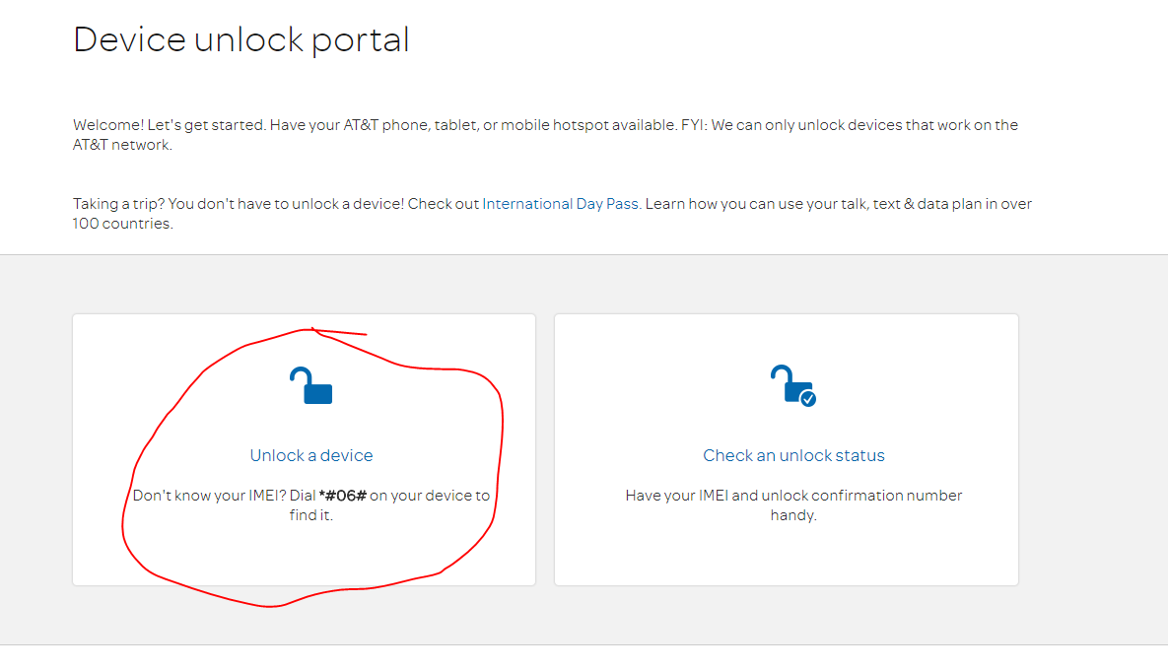

3. (Page 2 pic) **Fill in the blanks (no spaces or dashes) and check two boxes at bottom. Click next**

   If yes you are a customer-Wireless Number (found in phone contacts if you don’t know it)

   If no-IMEI number (found in settings) or dial *#06#

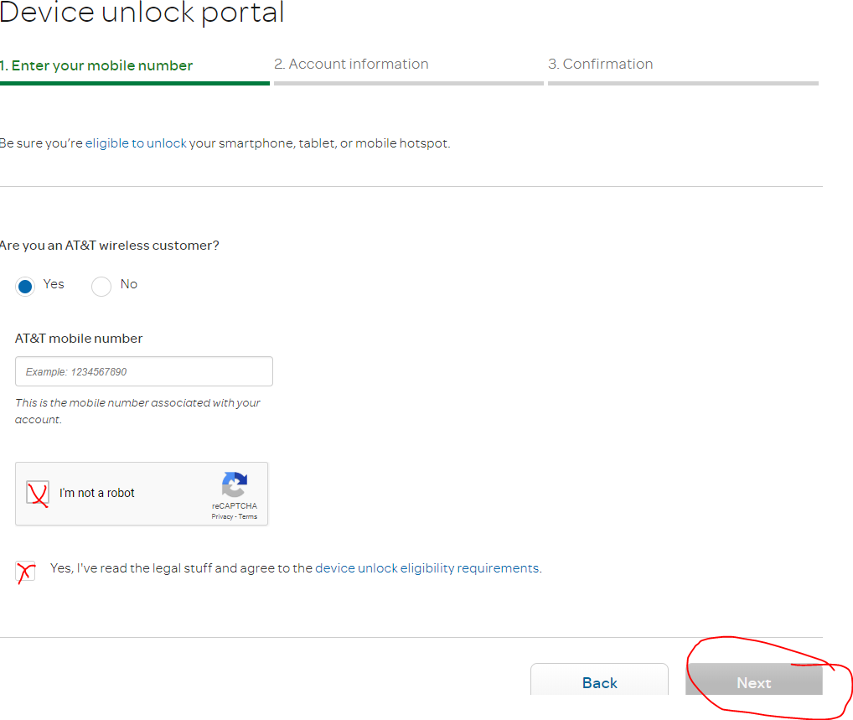

4. **Fill out info. Use any phone number and the email address provided in step 5. Click Submit**

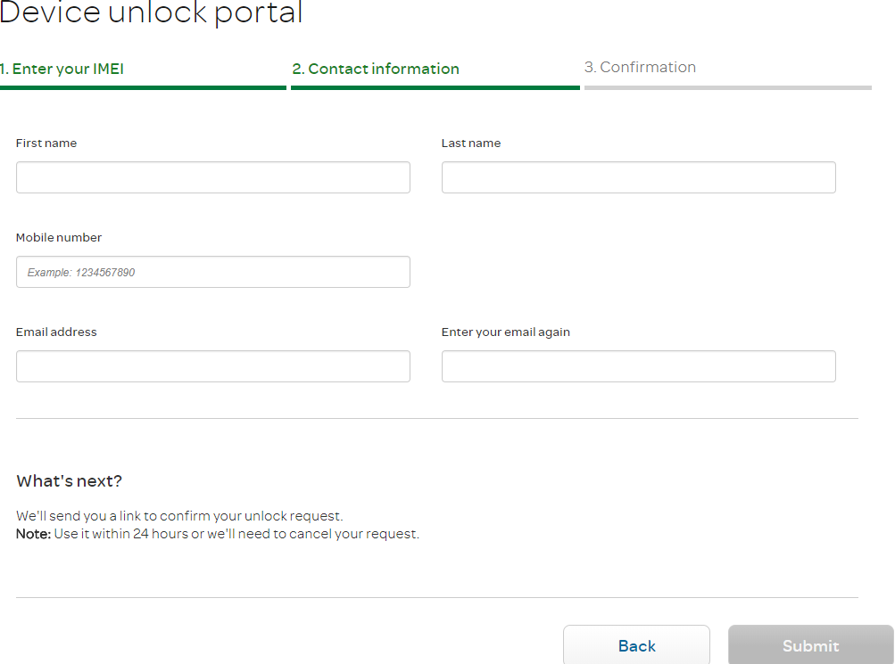

First Name ( No nicknames or partial names Chris and Christopher makes a difference. If not sure whose name is on account or what it is call AT&T or look at your bill statement.)

   Last Name

5. If you have questions or if something comes up you don't understand just ask or take a picture and email

fixit@mhrepairs.tech

https://mail.google.com/mail/u/0/images/cleardot.gif